

**AROR UNIVERSITY OF ART ARCHITECTUR DESIGN AND HERITAGE SUKKUR**

**ABDUL RAZAQUE**

**ROLL NO. ARI-F23-0002**

**Lab 04**

**SUBMITED TO SIR ABDUL GHAFOOR**

**TASK 01**

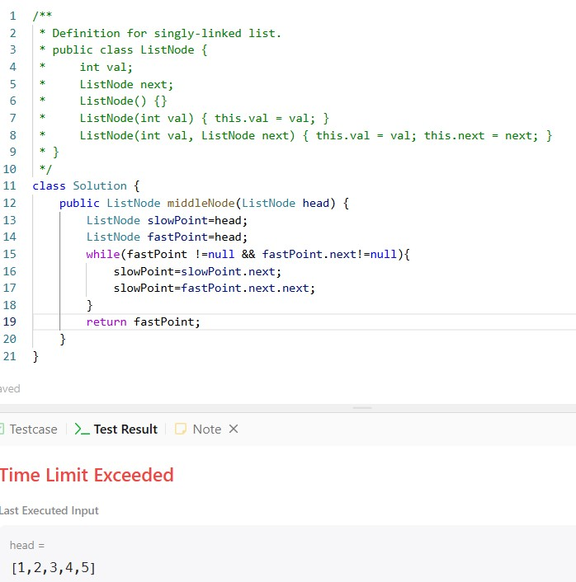

**TASK 02**

**TASK 03**

